UB Newcomers

Software Requirements Specification

Version 1.0

21st November,2020

Christian Hope, Elmer Sho, Devan Martinez
Software Engineers

Prepared for
Fundamentals of Computing: CMPS1134
Instructor: K. Ryan
Autumn 2020

Revision History

Date | Description | Author | Comments
21/11/2020 | Version 1.0 | Christian Hope, Elmer Sho, Devan Martinez | First Revision

Document Approval

The following Software Requirements Specification has been accepted and approved by the following:
Signature | Printed Name | Title | Date
C.Hope  D. Martinez  E. Sho | Christian Hope, Elmer Sho, Devan Martinez | Software Engineers | 21st November,2020
 | K. Ryan | Instructor, CMPS 1134 | 21st November,2020

Table of Contents

Revision History ii
Document Approval ii
1. Introduction 1
1.1 Purpose 1
1.2 Scope 1
1.3 Definitions, Acronyms, and Abbreviations 1
1.4 Overview 1
2. General Description 2
2.1 Product Functions 2
2.2 Assumptions and Dependencies 2
3. Specific Requirements 2
3.1 External Interface Requirements 3
3.1.1 User Interfaces 3
3.1.2 Hardware Interfaces 3
3.1.3 Software Interfaces 3
3.1.4 Communications Interfaces 3
3.2 Functional Requirements 3
3.2.1 <Functional Requirement or Feature #1> 3
3.3 Use Cases 4
3.3.1 Use Case #1 4
3.4 Classes / Objects 4
3.4.1 <Class / Object #1> 4
3.5 Non-Functional Requirements 5
3.5.1 Performance 5
3.5.2 Reliability 5
3.5.3 Availability 5
3.5.4 Security 5
3.5.5 Maintainability 5
3.5.6 Portability 5
3.6 Inverse Requirements 5
3.7 Design Constraints 5
3.8 Logical Database Requirements 5
3.9 Other Requirements 5
4. Analysis Models 6
4.1 Sequence Diagrams 6
4.3 Data Flow Diagrams (DFD) 6
4.2 State-Transition Diagrams (STD) 7
5. Change Management Process 8
A. Appendices 8
A.1 Appendix 1 8

1. Introduction
This document contains all of the information needed by the software engineers to adequately design and implement UB Newcomers Application described by the requirements listed in this document.

1.1 Purpose
The purpose of this SRS is written for Mr. Kieran Ryan.

1.2 Scope
(1) Software product(s); My SQL server, Node JS, My SQL, Miro, Click up, My SQL Database, Crud

(2) What do the software product(s) do; They help manage and create UB Newcomers project.

1.3 Definitions, Acronyms, and Abbreviations
Node JS - is an open-source, cross-platform, back-end, JavaScript runtime environment that executes JavaScript code outside a web browser.

Miro - is the online collaborative white boarding platform that enables distributed teams to work effectively together, from brainstorming with digital sticky notes to planning and managing agile workflows.

Clickup - is a cloud-based collaboration and project management tool suitable for businesses of all sizes and industries.

CRUD (Create, Read, Update, and Delete) - basic functions that models should be able to do, at most.

MySQL Database - is a fully managed database service to deploy cloud-native applications using the world's most popular open source database.

1.4 Overview
The rest of the SRS will contain all the diagrams, and information needed for the engineers to complete UB Newcomers.

2. General Description
This section of the SRS describes the general factors that affect UB Newcomers and its requirements.

2.1 Product Functions
The functions that the UB Newcomers will commit is evaluating which students from each high school is more likely to be accepted into the IT program

2.2 Assumptions and Dependencies
This subsection of the SRS should list each of the factors that affect the requirements stated in the SRS. These factors are not design constraints on the software but are, rather, any changes to them that can affect the requirements in the SRS. For example, an assumption might be that a specific operating system will be available on the hardware designated for the software product. If, in fact, the operating system is not available, the SRS would then have to change accordingly.

3. Specific Requirements
This will be the largest and most important section of the SRS. The customer requirements will be embodied within Section 2, but this section will give the D-requirements that are used to guide the project’s software design, implementation, and testing.

Each requirement in this section should be:
- Correct
- Traceable (both forward and backward to prior/future artifacts)
- Unambiguous
- Verifiable (i.e., testable)
- Prioritized (with respect to importance and/or stability)
- Complete
- Consistent
- Uniquely identifiable (usually via numbering like 3.4.5.6)

Attention should be paid to the carefuly organize the requirements presented in this section so that they may easily accessed and understood. Furthermore, this SRS is not the software design document, therefore one should avoid the tendency to over-constrain (and therefore design) the software project within this SRS.

3.1 External Interface Requirements

3.1.1 User Interfaces

3.1.2 Hardware Interfaces

3.1.3 Software Interfaces

3.1.4 Communications Interfaces

3.2 Functional Requirements

3.2.1 <Functional Requirement or Feature #1>
3.2.1.1 Introduction
Creates a web application to evaluate new students coming into UB
3.2.1.2 Inputs
Grades and reports offered from each student school and other student evaluations
3.2.1.3 Processing
Checks which students are qualified to take the IT course
3.2.1.4 Outputs
Outputs a yes or no to the administrator about each student qualification
3.2.1.5 Error Handling

3.3 Use Case
3.3.1 Use Case Diagram
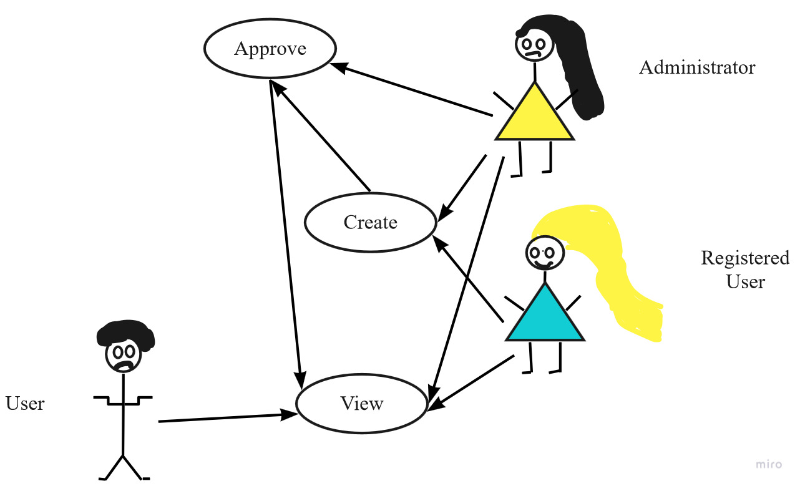

3.4 Classes / Objects

3.4.1 Class Diagram
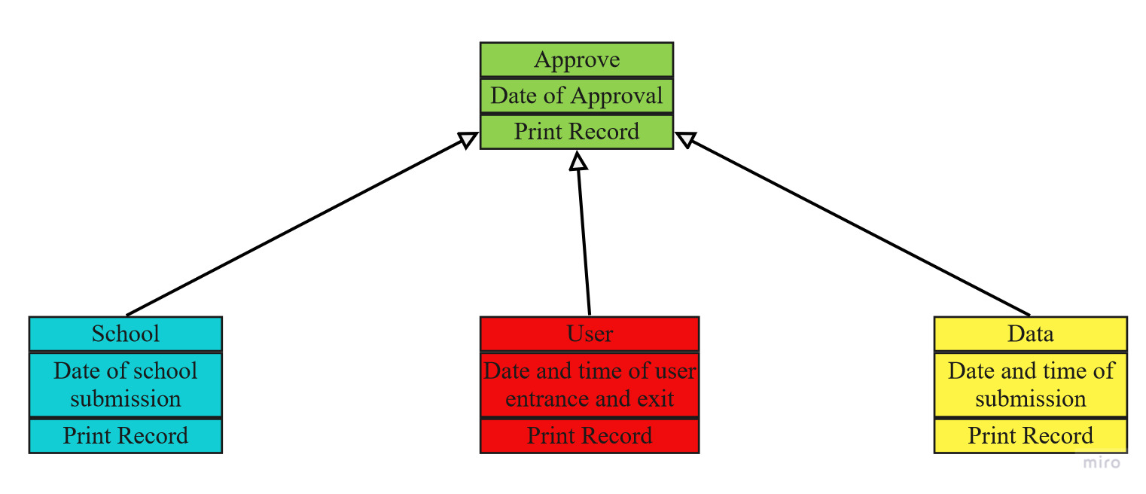
3.4.1.1 Attributes/ Function
School - keeps a record of all the high schools located in Belize.

User – keeps track of all the users entering the web application.

Data – makes sure the data corresponds with the user and school the user attends.

Approve – keeps track of how many applications where approved.

3.5 Non-Functional Requirements
Non-functional requirements may exist for the following attributes. Often these requirements must be achieved at a system-wide level rather than at a unit level. State the requirements in the following sections in measurable terms (e.g., 95% of transaction shall be processed in less than a second, system downtime may not exceed 1 minute per day, > 30 day MTBF value, etc).

3.5.1 Performance
It is not tested yet

3.5.2 Reliability
It will be really reliable once testing has finished

3.5.3 Availability
It will be available to everyone

3.5.4 Security
Not developed yet

3.5.5 Maintainability
It will be maintained by the developers and administrators who have access to the software

3.5.6 Portability
It will be an online web application

3.6 Inverse Requirements
State any *useful* inverse requirements.

3.7 Design Constraints
This software is still in the development stage and is not yet ready to be opened to the public to use.

3.8 Logical Database Requirements
A database was used in this software. It consists of ATLIB grades, highschools and students from those high schools. All the information is real and taken from the ministry of education.

3.9 Other Requirements
Catchall section for any additional requirements.

4. Analysis Models

4.1 Sequence Diagrams
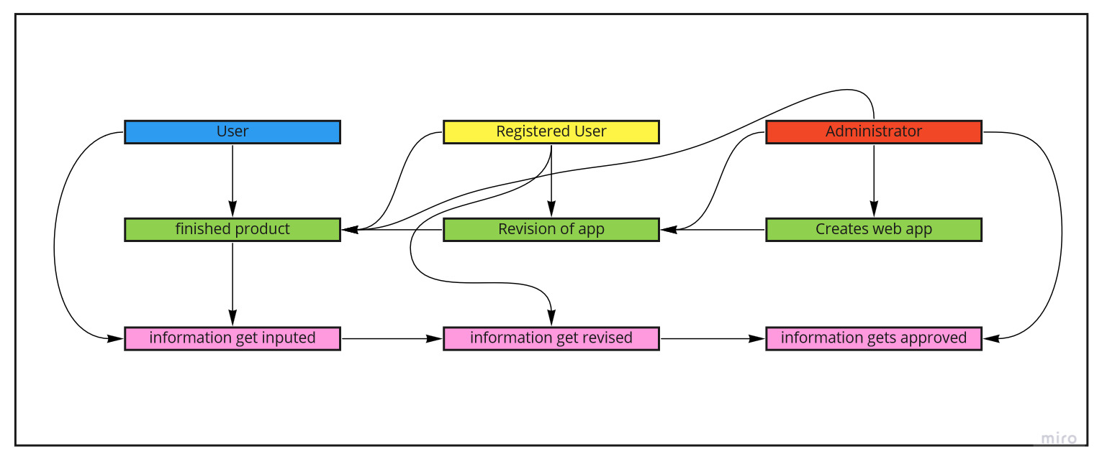

4.3 Data Flow Diagrams (DFD)
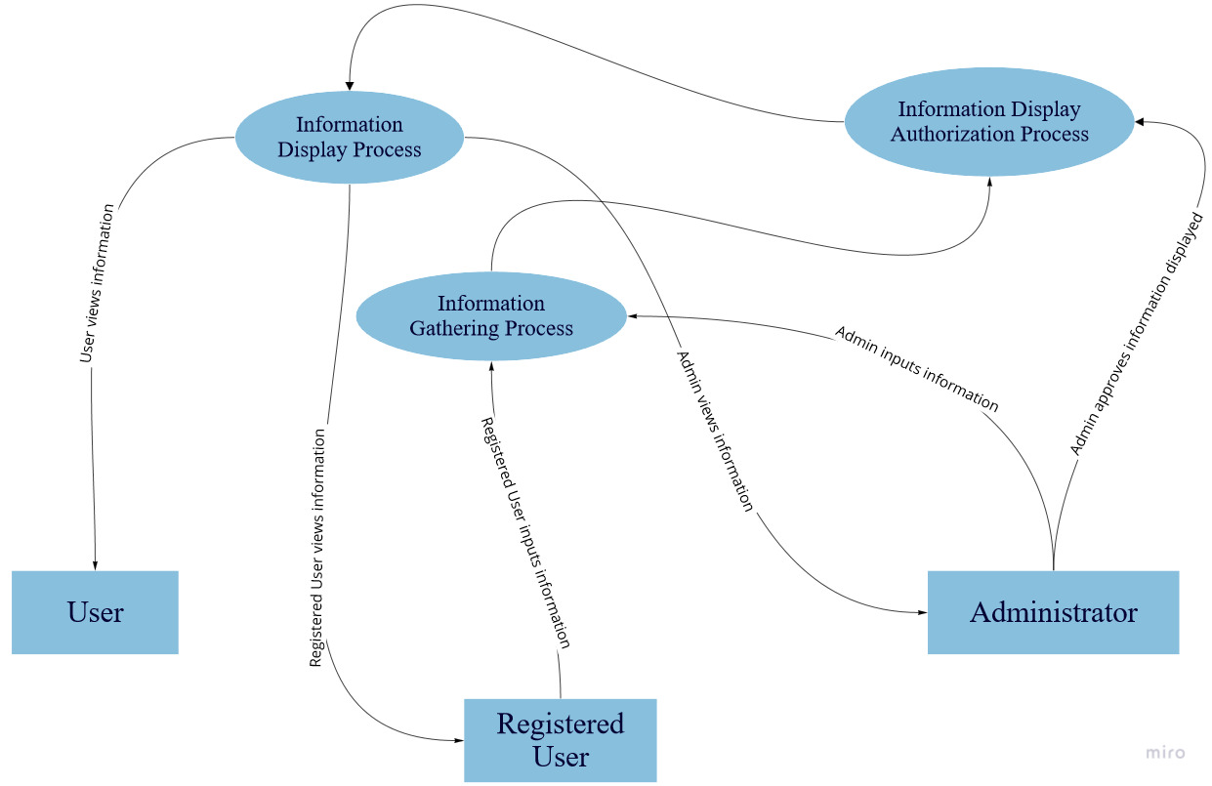

4.2 State-Transition Diagrams (STD)
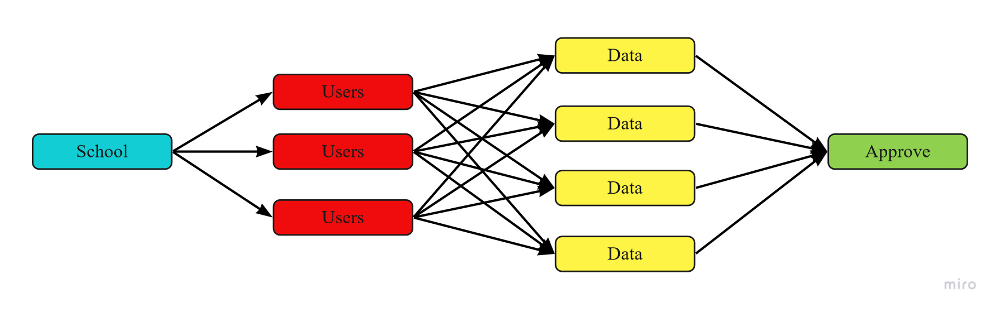

5. Change Management Process
This project will be changed everytime a function or requirement is added to UB Newcomers.

A. Appendices
Appendices may be used to provide additional (and hopefully helpful) information. If present, the SRS should explicitly state whether the information contained within an appendix is to be considered as a part of the SRS’s overall set of requirements.

Example Appendices could include (initial) conceptual documents for the software project, marketing materials, minutes of meetings with the customer(s), etc.

A.1 Appendix 1

A.2 Appendix 2

